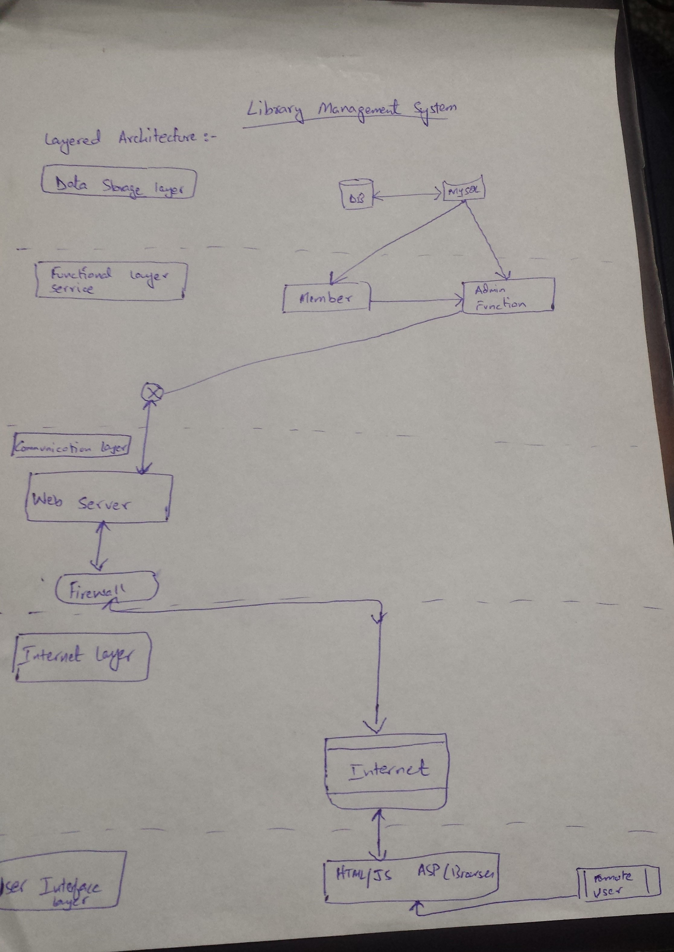

This is a layered Architecture, consisting of 5 layers.

1: Data storage Layer.

2: Functional Service Layer.

3: Communication Layer.

4: Internet Layer.

5: User interface Layer.

Data transfers occur in both directions in the system. The users input or data request is sent using either an internet browser or through the windows client. This data then connects to the system